
21st Aug 2004 6th Bhaadon, (Samvat 536) Nanakshahi

COMMUNITY VOICE

UNITED SIKHS SARBLOH CAMP IN NEW JERSEY AUGUST 2004.

Gagan Damama Bajio, parioh nischaney gao
Ket jo mand-io surma, ab joojan ka dao
Soora so pehi-chanehya, jo lareh deen keh het
Purja Purja kut mureh, kabahoo na chad-eh ket

The battle-drum is beaten in the (mind's) sky, the target is pierced through
The warriors enter the battlefield (against vice), now is the time to fight
One is known as a warrior only if one fights for righteousness
Even being battered to bits they never desert the battlefield: Bhagat Kabir.

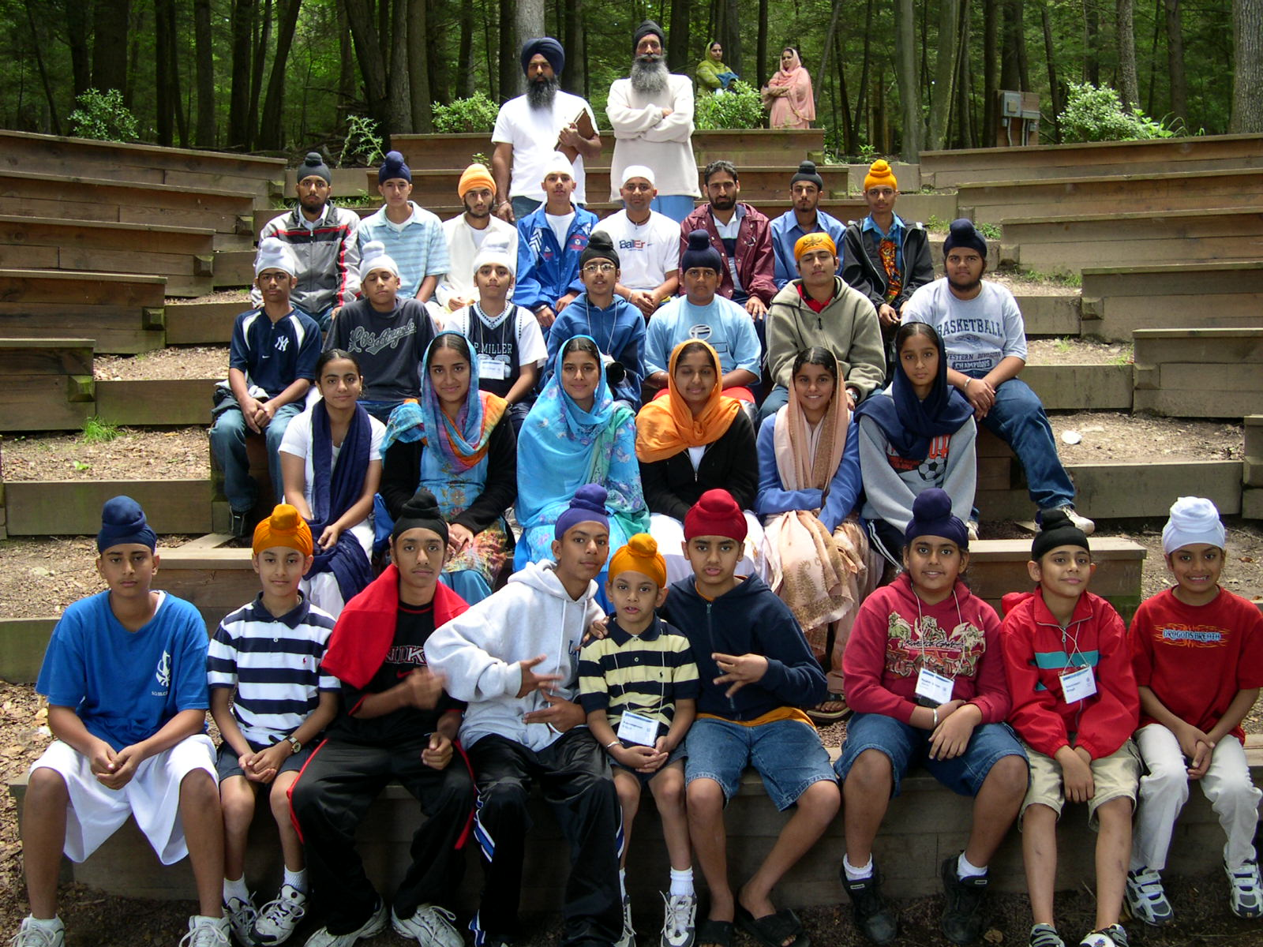

The UNITED SIKHS SarbhLoh CAMP in New Jersey was an endeavor to expose young Sikhs in the US to the principles and goals of Sikhism. It was an attempt to create a Sikh environment and provide a glimpse into the Sikh way of life. To help our youth identify their roots, Sikh History was an important focus of the camp. Seminars, discussions, sports, and various competitions were also held.

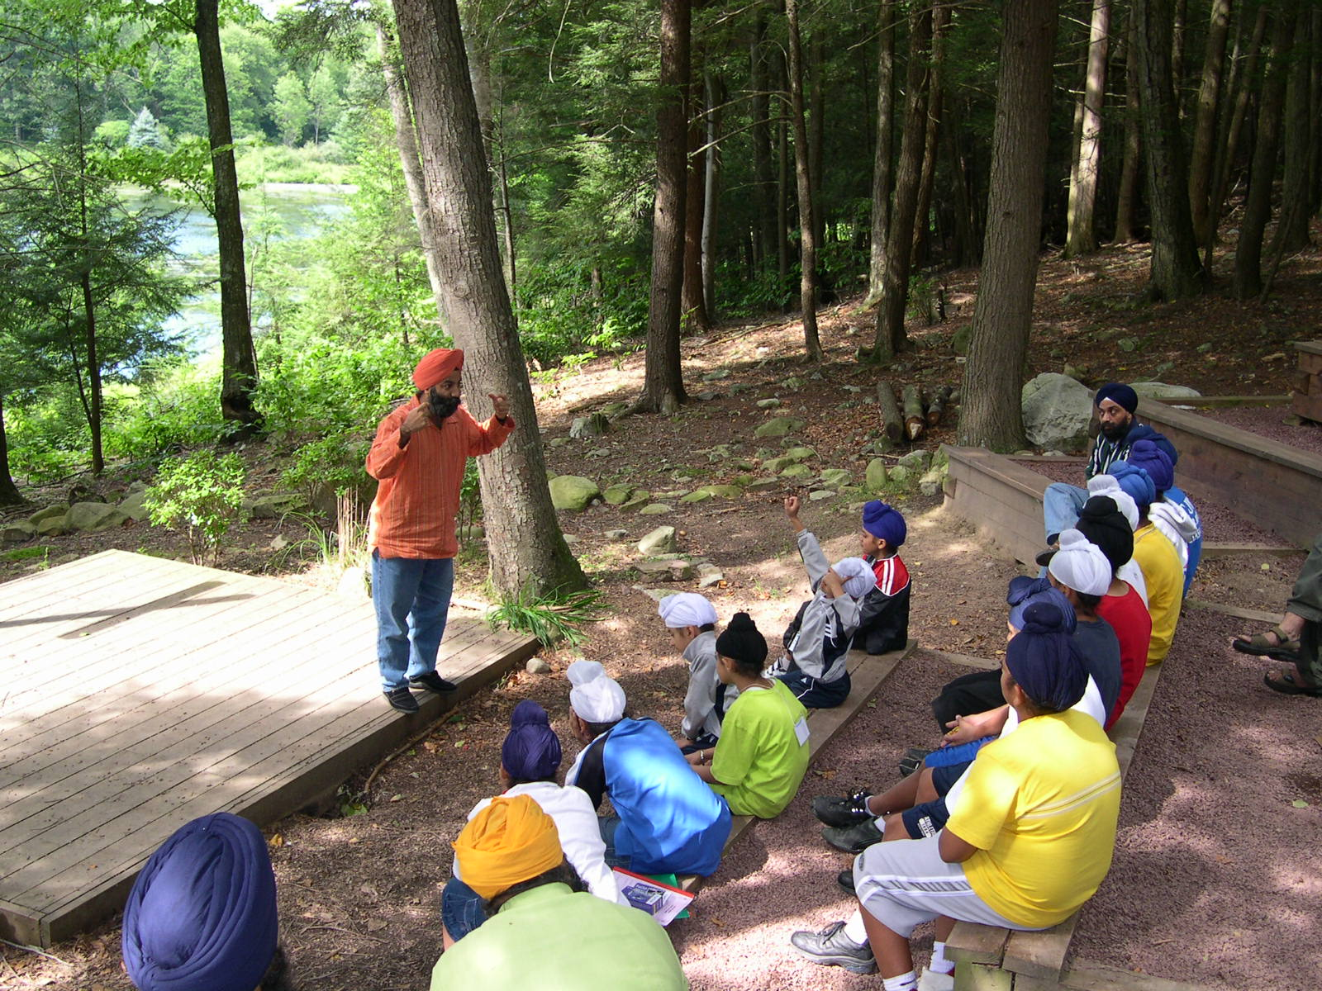
A series of SarbLoh camps will be held in Punjab throughout the year. Each camp will run for 3 months, the first one beginning in October 2004. The first Autumn SarbLoh camp in Punjab will start with a one-week residential camp at Khalsa College Amritsar, the 112 year old college which was the inspiration of the Singh Sabha movement. This will be followed by day camps throughout the week and weekends. The finale will be a one-month summer SarbLoh camp in Dalhousie. Students from Khalsa College and Guru Nanak Dev University and visiting campers from the UK and US will attend the camps, which will feature Gurbani, Keertan Maryada, Sikh history, culture and heritage, Gatka, guest lectures on current affairs, career and course counseling and field trips.

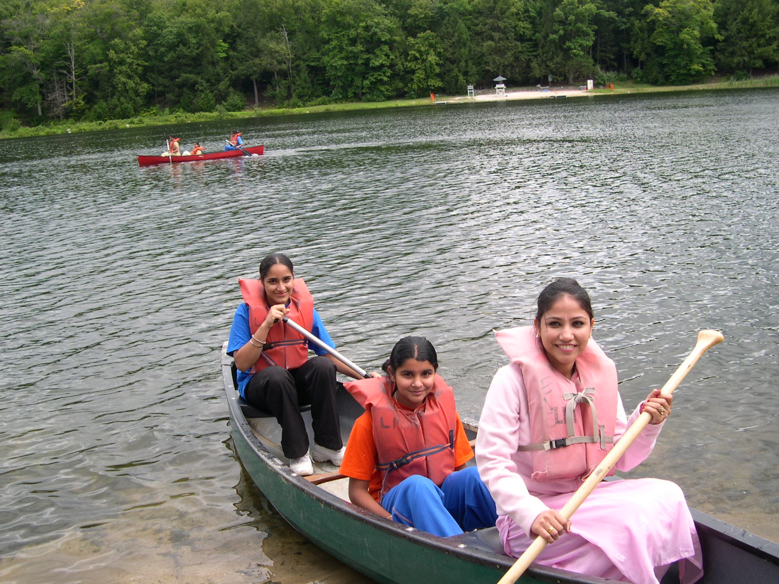

The first SarabLoh Camp in North America was held at Linwood Macdonalds in New Jersey in the heart of the Kittatinny Mountains in Sussex County at the border of Pennsylvania & New Jersey from August 6 to August 8, 2004 for two nights and three days.
The main objectives of the Camp were:-
- To quench the thirst of knowledge of Sikhi and provide fun, friendship and fantastic life long memories.
- To help youth to trace the footsteps of the Gurus, through Gurbani, Gatka and Seva.
- To instill the spirit of Naam Japna,(recite name of God) Vand Shakna, (caring and sharing) Kirt karni (Dignity of labour) and spirit of Chardi Kala (positive thinking).

There were about 52 attendees in all who attended the camp. The camp was held under the UNITED SIKHS banner with the kind cooperation of the Sangat and committee of Gurdwara Sahib of Glen Rock. UNITED SIKHS directors Jagjit Singh and Sandeep Kaur were camp-cordinators. The campers learned about Sikh History, Rise & fall of Sikh power from Prabhsharandeep Singh, assistant Professor of Religion at Berkeley University. Richipal Singh imparted knowledge on Sri Guru Granth Sahib ji about its compilation, pronunciation and grammar. Dhanvir Singh (Bitoo) explained the meaning of Ardaas. Simran Kaur took the classes on Music and Shabad Kirtan in the morning and evening.

Hardayal Singh conducted a workshop on Human Rights. Kuldeep Singh introduced the projects undertaken by UNITED SIKHS all over the world. Sandeep Kaur conducted the women empowerment program. Sikh martial art, Gatka, was one of the most interesting items enjoyed by the students.

A lecture on Basic Principles of Sikhism was conducted by visiting Professor S. Lal Singh from Bombay. Dr. Amarjit Singh, a human rights activist spoke on identity issues of the Sikhs and the UN human rights conventions.

UNITED SIKHS group leaders Daljit Singh, Davinder Singh, Simran Kaur and Avinash Kaur were kept on their toes to ensure the smooth running of the camp.
A skit on the caste system was played by the campers guided by, Kuldeep Singh.
For more information on the Right to Turban campaign, please link to:
http://unitedsikhs.org/rtt/index.htm

Our Mission
To transform underprivileged and minority communities and individuals into informed and vibrant members of society through civic, educational and personal development programs, by fostering active participation in social and economic activity. UNITED SIKHS is also an avenue for networking between like-minded organisations to establish and nurture meaningful projects and dialogues - whether social, cultural or political- to promote harmony, understanding and reciprocity in our villages, towns and cities. UNITED SIKHS is a coalition of organisations and individuals, who share a common vision based on the belief that there is no greater endeavor than to serve, empower and uplift fellow beings. The core of our philosophy is an unwavering commitment to civic service and social progress on behalf of the common good. Accordingly, UNITED SIKHS has sought to fulfill its mission not only by informing, educating and uplifting fellow beings but also by participating in cross-cultural and political exchanges to ensure that the promises and benefits of democracy are realized by all. We at UNITED SIKHS believe that the development of enlightened and progressive societies can be made possible by socially conscious groups of people who make a commitment to develop and direct human potential. Our work, efforts and achievements stand as a testament to our faith in this vision.

