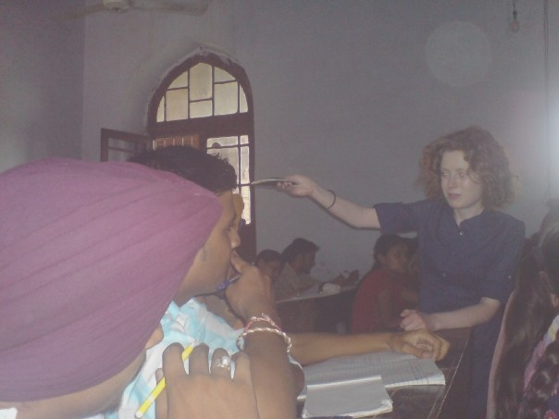
Are you interested in teaching English this summer?

Would you like to experience the rich and vibrant culture of Punjab at the same time?

Are you free from July 26th - August 27th?

If your answers to all the above questions are " yes " please read about the UNITED SIKHS - Oxford University TravelAid project at http://www.unitedsikhs.org/usouta and download and complete the application and health history forms from the " downloads " section on this webpage to apply to join the project. Please email your completed forms asap to volunteer@unitedsikhs.org ensuring that you sign, scan and email the sections of the forms which require to be signed by you.

