April 7, 2006

DENNIS PIERRO
Capital Fitness, Inc
47 W210 Route 30
Big Rock, IL 60511
cc: DALE J RACZKOWSKI
cc: Harmeet Singh
cc: American Sikh Consultative Forum (ASCF)

Re: Right To Wear a Turban: Harmeet Singh of Willowbrook,IL,

Re: Harmeet Singh's Employment at X Sports Fitness

Dear Sir:

On behalf of UNITED SIKHS ( www.unitedsikhs.org) and the Sikh American community, we would like to applaud you for paying heed to your employee, Harmeet Singh’s, right to practice his religion at the workplace, as protected by the Illinois Human Rights Act.

We were approached by Harmeet Singh to advise him as to his rights after he was informed by his manager that he could not wear his Turban whilst working as a Fitness Instructor. We advised and guided him to write to you under the procedure set down by your company’s Corporate Equal Opportunity and Non-Discrimination Policy and Procedure. We are very pleased that your company operates a policy which complies with state and federal law. We hope that Harmeet Singh continues to be a valuable asset to your organization and provides you with many years of loyal service.

Sincerely:
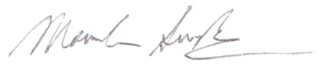
Manvinder Singh
Director
International Civil and Human Rights Advocacy Directorate
UNITED SIKHS

